**International Travel Policy**

**December 4, 2023**

**1. Purpose**

This International Travel Policy outlines the guidelines and procedures for employees of Ha-Meem Group, traveling internationally for business purposes. The policy aims to ensure employee safety, control costs, and maintain company standards during international travel.

**2. Travel Authorization**

#### **Approval Process for Planned Trips:**

* **Travel Plan Submission:** One month before a planned trip, the traveler(s) must prepare an itinerary and a detailed trip plan, including the purpose, specific objectives (including details of meetings and desired outcomes), and required resources. This plan, along with the list of items to be taken and any necessary personnel support from the company, will be submitted to the respective Travel Supervisor. The Travel Supervisor is the head of the traveler's respective department, unless stated otherwise. A template for the *Travel Plan* can be found in the Index but there is no set format that must be followed, as long as each point stated above is addressed.
* **Travel Supervisor's Approval:** The Travel Supervisor will check the trip against the budget and approve the travel if everything is in order. The approved plan will serve as the basis for the trip and as the requisition for booking all travel and accommodations.

#### **Approval Process for Unplanned Trips:**

* **Unplanned Trip Justification:** For unplanned trips, the same preparation process applies, but a justification must be provided in the travel plan. This justification should explain why the trip wasn't included in the annual review and why it is necessary.
* **Travel Supervisor's Assessment:** If the Travel Supervisor deems the unplanned trip necessary, they will escalate it to the zonal head (MD for Head Office staff) for final approval.

#### **Flow Chart and Reference:**

* A detailed flow chart illustrating the entire approval process is provided in the index for reference, ensuring clarity and transparency in the travel approval procedures.

**3. Travel Expenses**

* **Airfare:** Employees are expected to book the most economical and direct flights. All tickets must preferably be refundable. If there are no valid tickets available, special approval must be taken by the travel supervisor to book a non-refundable ticket. Business class travel is permitted for DMD designation and above.
* **Accommodation:** Standard rooms must be picked from any of the approved hotels. Approved hotel options, for each designated location, and their usual rates are listed in the *International Travel Rate Sheet*, which will be maintained and updated by the Travel Manager. The rates are only a reference to be used when booking; the actual price may vary. If none of the approved hotels are available, the destination is not listed in the Rate Sheet, or better options are available that suit the purpose of the travel, special approval may be taken from the travel supervisor. All hotel bookings should remain within the approved accommodation budget.
* **Transport, Meals, and Incidentals:** Expenses will be reimbursed at actual cost. Travelers should be aware of and maintain the expense budget for their given trip, with proper documentation and justification for over-budget expenses. Receipts are required for all expenses to be reimbursed. In special cases where receipts cannot be collected, the guidelines below on *Non-Receipt Expenses* should be followed. For local transport, a provider like Uber or Lyft should be used where available.
  + **Expense Report:** All business-related expenses not related to meals, tips, or small cash purchases must be properly documented in the Expense Report. The Expense Report, along with digital images of all receipts will then be submitted to the travel supervisor for approval. If approval is given, Accounts will reimburse the expenses. The *Travel Expense Report* can be found in the Index.
  + **Cash Advance:** Once the approved Travel Plan is submitted to the Travel Manager, they will be provided the appropriate cash amount-as per the budget-for daily allowances and hotel fees for the given trip to be disbursed to the respective traveler(s).

**5. Health, Safety, and Compliance**

* Employees should be aware of health and safety guidelines provided by the local authorities of the country of destination.
* Vaccinations and health check-ups may be mandatory depending on the destination. Employees must comply with these requirements.
* Employees must adhere to this policy and local laws and regulations of the destination country. Violations of this policy may result in disciplinary action.

**6. Travel Documentation**

Employees are responsible for ensuring they have a valid passport, visa, and any necessary permits for international travel. If any support is required, especially with the VISA process, the travel desk and HR department is available for assistance.

**7. Communication**

Employees should maintain regular communication with their supervisor during their trip, providing updates on their meetings and checking in

**8. Personal Time**

Any personal time taken during business trips is the responsibility of the employee, including additional accommodation and expenses.

**9. Invoice Payment**

All invoices must be paid within 15 days of receipt. The responsible parties are expected to coordinate in order to ensure smooth payment of bills. Any late fees incurred due to late payments may result in disciplinary action of the accountable party. Accountability structures will be set in the Annual Budget Reviews.

**10. Audit Oversight**

To ensure the adherence to our international travel policy and maintain the integrity of our financial processes, our Audit department will conduct post audits of the expenses of each travel. The Travel Manager will be responsible for submitting the Travel Plan and itinerary for each trip, and Accounts will be responsible for submitting the Expense Report after all processes are complete. Employees are required to comply fully with the Audit department by providing any additional data, receipts, or other materials upon request. These audits will take place after trips are complete to prevent any disruption or slowdown in the travel process. Your cooperation in this regard is crucial to maintaining transparency, accountability, and the smooth functioning of our travel procedures.

**11. Quarterly and Annual Budget Reviews:**

* **Quarterly Reviews:** A quarterly review of the travel budget will be conducted by the Travel Supervisors to review the expenses and outcomes of the completed trips for each quarter. Any discrepancies in the budget, unplanned trips, or missed trips that were approved in the budget will be addressed here. Responses to these queries will be evaluated in the annual review process.
* **Annual Budget Setting and Prior Year Review:** Annually, the heads of Marketing, Accounts, and Audit will convene to review the previous year's budget and set the travel budget for the upcoming year. This meeting is the designated time to add or remove planned trips from the budget. Trips approved in the budget are assumed necessary. Failure to undertake an approved trip without justification will result in a query during the Quarterly review. Responses to queries during Quarterly reviews will be considered in the Annual review to determine the necessity of the trips in question for the following year's budget.

**Index**

All relevant documents will be available for distribution upon request with HR and the Travel Desk.

**I.1 Travel Plan Form**

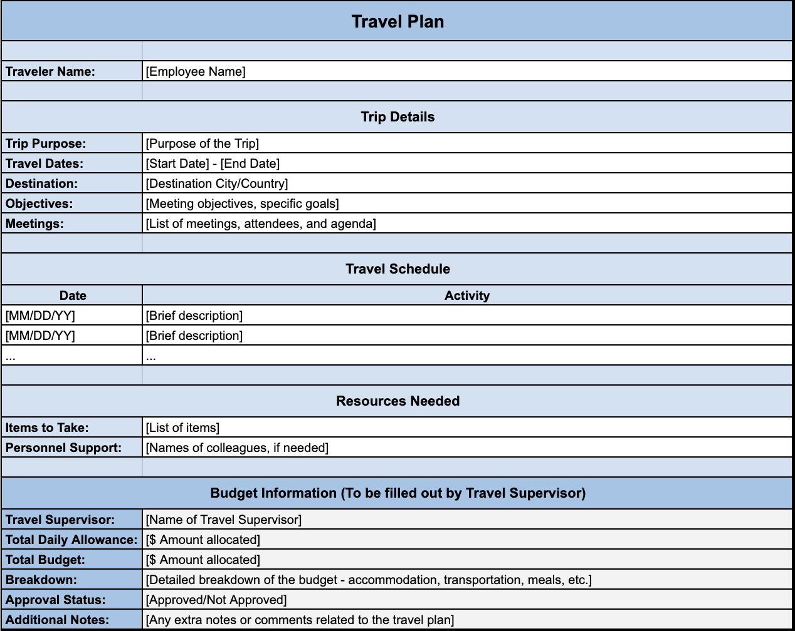

**I.2 Expense Report**

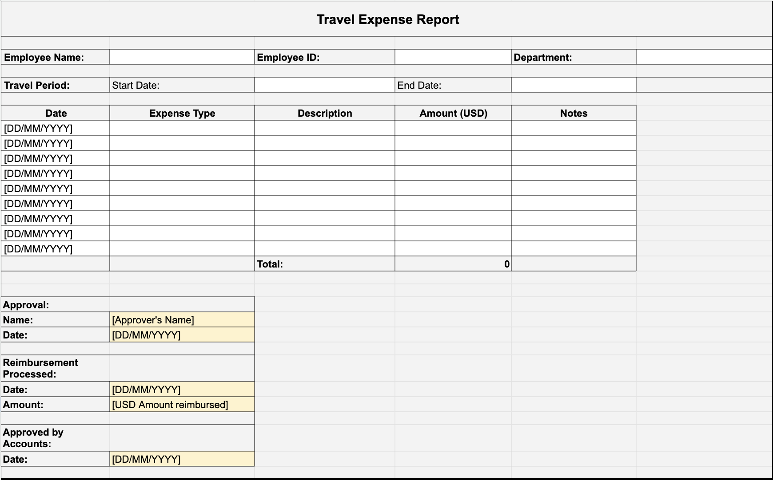

**I.3.1 Travel Authorization Flowchart - Traveler**

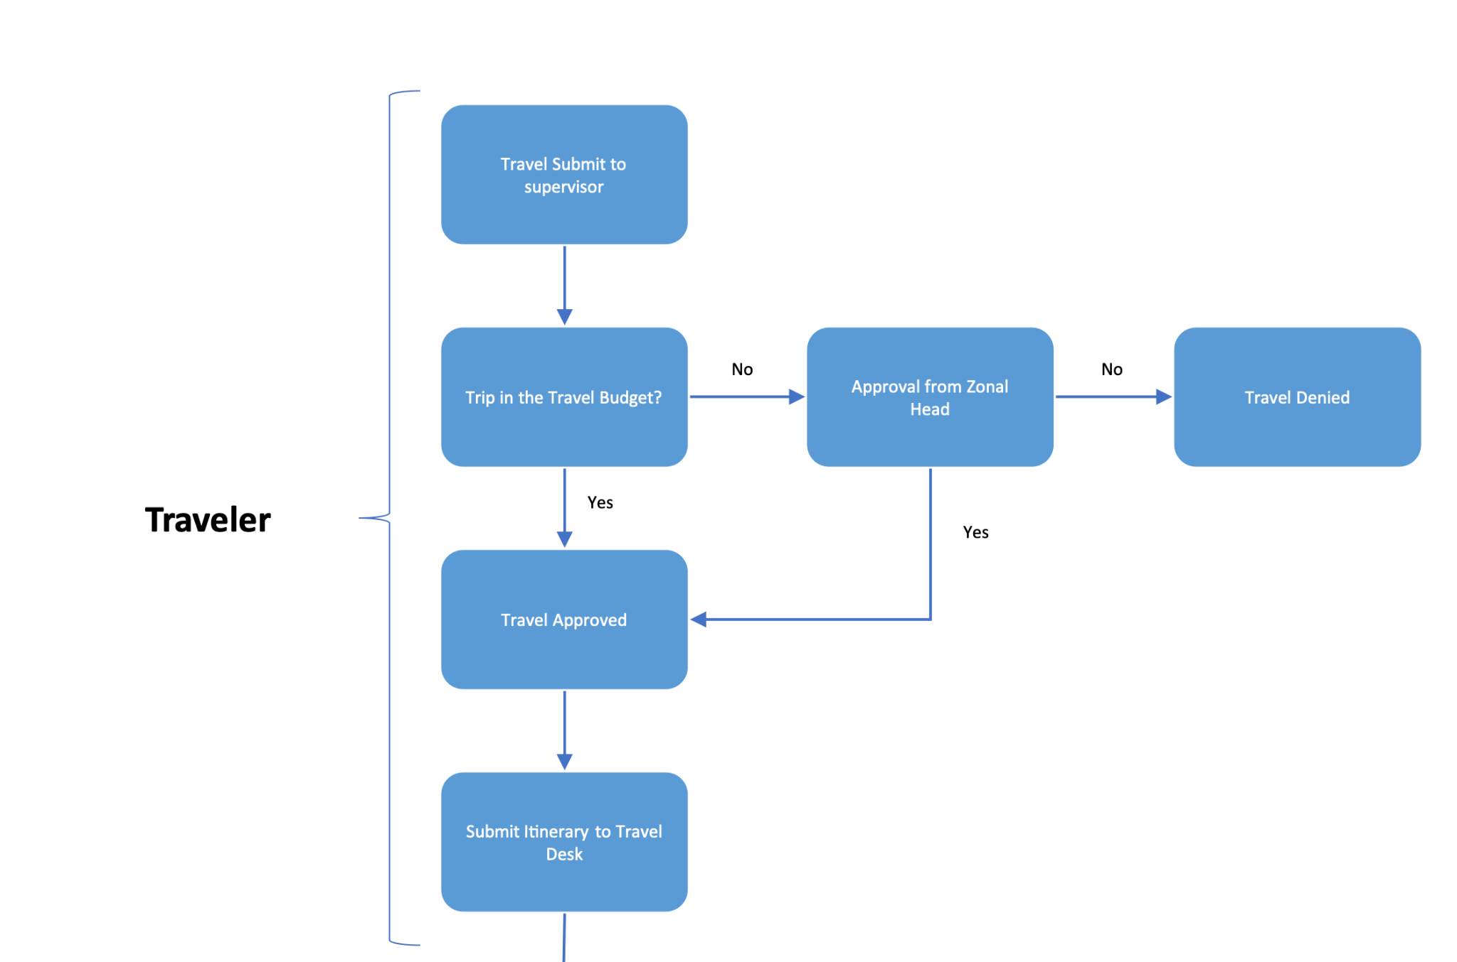

**I.3.2 Travel Authorization Flowchart - Travel Manager**

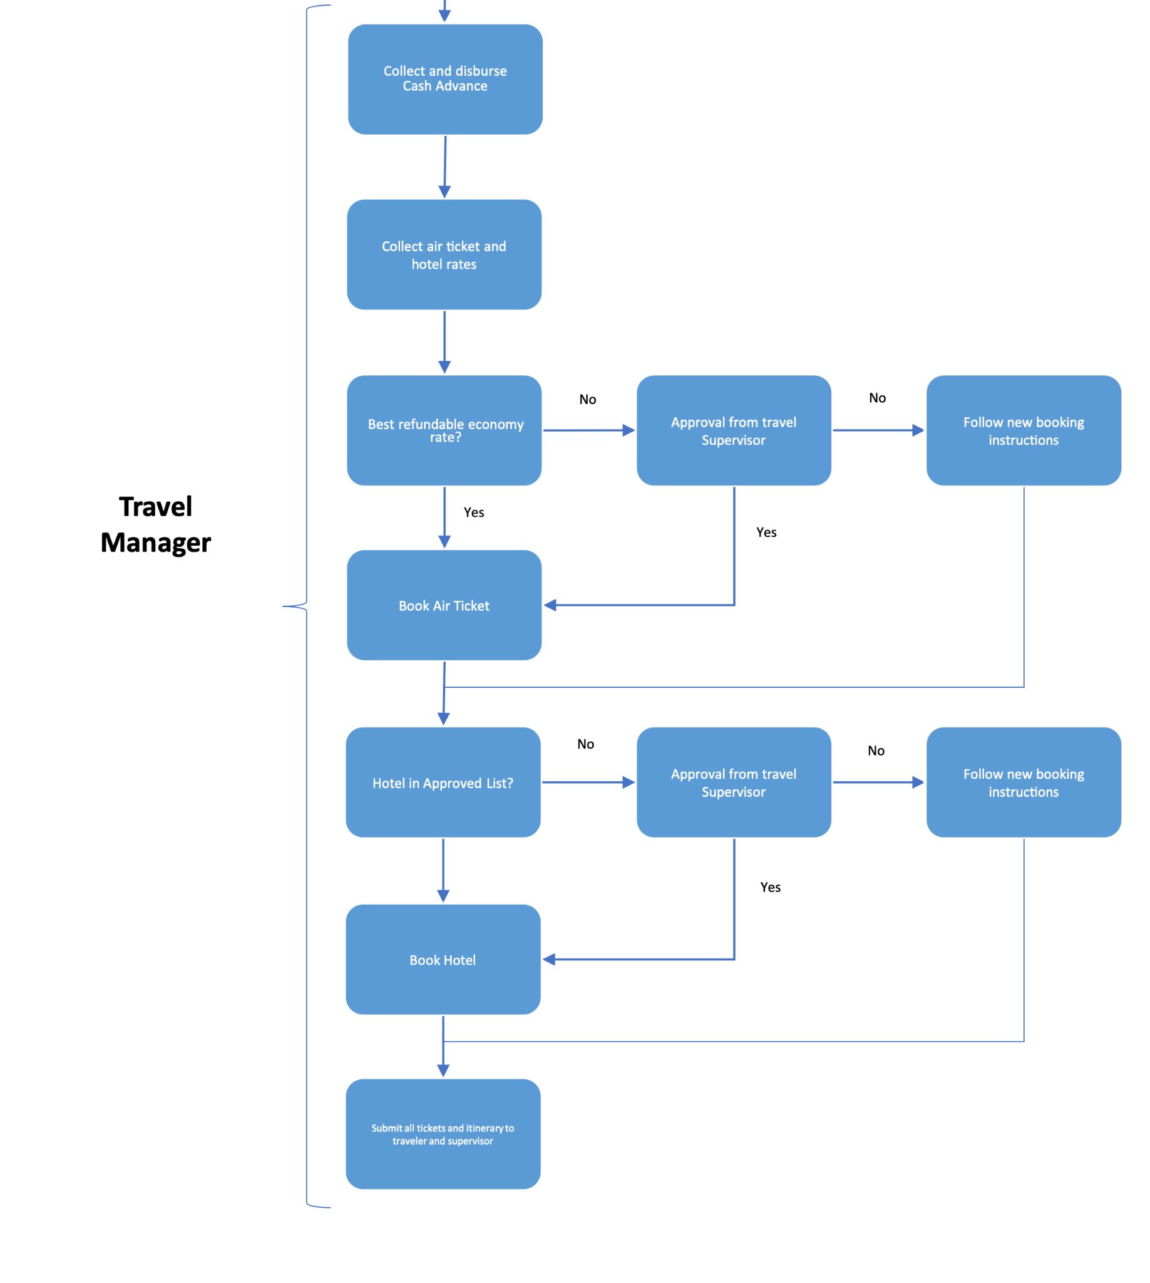

**\*Regarding "Follow new booking instructions", if approval is not given by travel supervisor for non-compliant ticket/hotel purchases, they will provide new booking instructions to follow.**